Your After Disaster Go-To-Guide &
Point Dume Community Brigade/Firewise Update
Volume 1: January 2026

How you spend your precious time and energy here on earth matters.

We invite you to spend some time now to preparing for whatever disaster may come next. Your family and your community will be better off because of your advance preparation and Disaster Intelligence. Thank you for taking the time to get ready.

1) Infrastructure & Hardware: What do you have right now?
After a disaster, help may or may not come. Living in Malibu, we know, you are most likely on your own. The question to answer today is simple:
If utilities are down and you’re on your own for 72 hours… what can your home and neighborhood actually do to help you?

A. Water Supply
Check what you have and what’s usable:
- Water tank / cistern (capacity, location, access)
- Pool or spa water (NOT for drinking, but valuable for firefighting/clean-up)
- Garden hose hookups (do they work if power is out?)
- Rain barrels (if any)
- Drinking water stored (goal: 1 gallon per person per day × 3–7 days)
Action: Write down your water sources + where the gas shutoff valve is.

B. Power & Pumping
Most water systems rely on power. Know your backup:
- Generator (fuel type, where stored, tested?)
- Battery backup / solar + power station
- Well pump / pool pump (can it run without grid power?)
- Extension cords / adapters you’d need to actually use it
Action: If you have a generator, run it for 10 minutes this week.

C. Firefighting Tools (for defense + ember control)
Only if it’s safe and you are going to get training:
- Hoses (length, condition, stored where?)
- Nozzles (adjustable spray)
- Sprinklers / rooftop sprinklers (if installed)
- Pumps (trash pump / portable pump, if you have one)
- 5-gallon buckets + bucket brigade plan
Action: Stage hoses/nozzles where you can grab them fast.

D. Personal Protective Gear (PPE)
Fire aftermath is hazardous—ash, toxins, sharp debris:
- N95/P100 masks
- Goggles
- Work gloves + heavy-duty boots
- Long sleeves / durable pants
- First aid kit
- Headlamp / flashlight
- Hard hat (optional but helpful in debris areas)
Action: Make a small “PPE bin” by the door.

E. Tools for Clean-up & Access
- Shovels / rakes / broom
- Crowbar / pry bar
- Utility knife
- Tarps + duct tape
- Contractor trash bags
- Fire extinguisher
Action: Create a “tools tote” so it’s all in one place.

F. Communications When Cell Towers Are Down
This is huge:
- Battery-powered radio / NOAA radio
- Extra charging cables + power banks
- Satellite phone (if you have it)
- Satellite internet / hotspot (Starlink or similar)
- Walkie-talkies / GMRS radios (great for neighborhoods)
- Printed contact list (paper still works)
Action: Choose your family “out-of-area contact” and put it on paper.

G. Do You Know Your Neighbors? How will you coordinate? (This is infrastructure too)
- Neighbor buddy list (3–5 nearby contacts)
- Who has water, who has generator, who has medical training, who has chainsaw
- Meeting point and check-in times if communications fail

PointDumeCommunityBrigade.com and Firewise Community update
Last year we met in person on April 2, 2025, at a home on Point Dume. We watched a presentation from the City of Malibu on how to create a Firewise Community. See Firewise USA Assistance - Ventura Regional Fire Safe Council. We discussed how the Firewise program works at the meeting.
Home hardening assessments are free and we also discussed the importance of hardening our community as well.
On May 5, 2025, we were granted officially recognized and granted Firewise Status. (Thank you, City of Malibu, for your help).
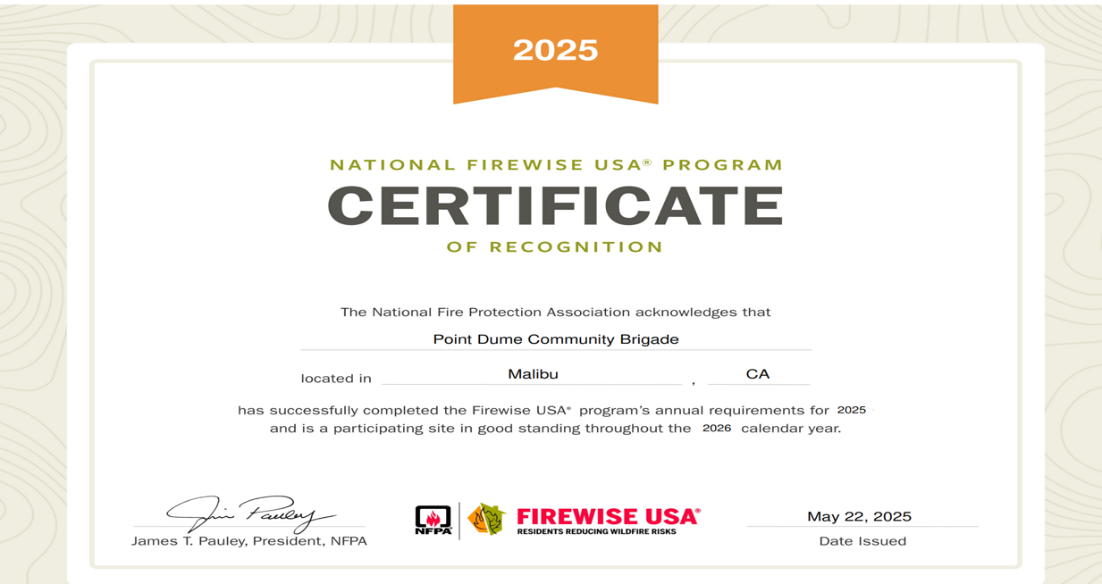
Since then, we worked with many neighbors to clear brush in and around Point Dume homes. We also had goats come to several properties to help clean up the Gully near the Point Dume Elementary School.
Our Point Dume Neighbors will meet again this year on Thursday April 2, 2026, at 2 p.m. to make sure we can start neighborhood check in lists for the most vulnerable and coordinate with neighbors if help doesn’t arrive. (Email pamelaconleyulich@gmail.com for information and to RSVP.)
We can and must make this a year to continue to learn and grow stronger together.
Thank you!
Here is more in-depth information on how to schedule your free home hardening assessment and why it matters from the City of Malibu:
HOME WILDFIRE ASSESSMENTS
“During a wildfire, thousands of embers can rain down on your home and property like hail during a storm. If these embers land in receptive fuels or become lodged in something easily ignited on or near your house, the home may be in jeopardy of burning. This area is commonly referred to as the Home Ignition Zone.
Embers coming into contact with flammable material is a major reason why homes are destroyed during a wildfire. Common materials that become embers during wildfire include palm fronds, branches, tree bark, and native vegetation. Depending on fire intensity, wind speed, and the size of materials that are burning, embers can be carried more than a mile ahead of the fire. Consequently, even homes located blocks away from the actual flame front are vulnerable to ignition and complete destruction. By being ember aware and taking action ahead of time, a homeowner can substantially reduce the ember threat.
Utilizing City staff and certified volunteers, the city offers no-cost, no-obligation Home Wildfire Assessments to assist residents by providing recommendations for hardening their homes against flying embers.
Visit the online scheduling system to set an appointment for your home assessment.
Watch a video on how your home could survive a wildfire from the National Fire Protection Association (NFPA). In the video, Dr. Jack Cohen, Fire Science Researcher with the USDA Forest Service, explains current research about how homes ignite during wildfires, and the actions that homeowners can take to help their home survive the impacts of flames and embers.”

